***TP (modèle linéaire)***

***\*Les instructions d’exécution dans R :***

library(FactoMineR)

coron<-c(1,0,1,0,0,1,0,0,0,0,0,0,0,1,0,1,0,0,0,1,0,1,1,1,0,1,1,1,0,0,1,0,0,0,0,0,1,1,0,0,0,1,0,0,0,0,0,0,0,1,1,1,0,1,0,0,1,0,1,0,0,0,1,1,0,1,1,0,1,1,0,0,0,1,0,1,1,1,0,0,0,0,0,1,1,0,0,0,0,1,1,1,0,0,0,0,0,1,0,0)

hta<-c(0,0,1,1,0,0,0,0,0,0,0,0,0,0,0,0,0,0,0,0,0,0,1,0,0,0,0,0,0,1,0,0,0,0,0,0,0,0,0,0,0,0,1,1,0,0,0,1,0,1,1,1,1,1,1,0,1,1,1,0,1,0,0,0,1,0,0,0,0,0,1,0,0,0,0,0,0,0,1,1,0,0,0,1,0,0,1,0,0,1,1,1,1,0,0,0,1,1,1,1)

sex<-c(1,1,1,1,1,1,1,1,1,1,1,1,1,1,1,1,1,1,1,1,1,1,1,1,1,1,1,1,1,1,1,1,1,1,1,1,1,1,1,1,1,1,0,0,0,0,0,0,0,0,0,0,0,0,0,0,0,1,1,1,1,1,1,1,1,1,1,1,1,1,1,1,1,1,1,1,1,1,1,1,1,1,1,1,1,0,0,0,0,0,0,0,0,0,0,0,0,0,0,0)

age<-c(47,58,44,67,60,72,54,56,67,49,69,64,73,49,68,58,81,49,69,38,75,82,75,51,66,43,33,85,51,83,47,81,61,60,34,33,58,73,81,56,70,82,62,77,57,49,71,42,75,42,79,96,77,76,79,76,62,54,53,53,66,66,62,48,54,42,63,62,55,79,72,66,59,84,67,76,82,71,70,66,52,46,30,60,58,70,63,60,57,77,83,29,28,29,75,40,56,31,73,70)

chol<-c(1.25,1.12,1.24,2.19,0.91,1.29,2.28,2.09,1.19,2.78,1.34,1.15,1.93,1.92,0.95,1.25,2.25,1.21,1.24,1.13,1.69,1.96,1.37,1.36,1.07,1.58,1.5,1.71,1.5,1.62,1.65,1.72,1.87,1.35,1.28,1.88,1.73,1.85,1.44,1.39,1.96,1.44,2.19,1.07,1.22,2.31,1.7,2.46,1.87,2.05,1.62,1.61,1.53,1.54,2.06,2.53,0.79,1.25,1.22,1.23,2.21,1.02,1.03,1.24,1.25,1.26,1.43,1.92,2,1.29,0.8,1.22,1.19,1.13,1.57,1.72,1.41,1.07,1.58,2.22,1.05,1.04,1.22,1.22,1.88,2.16,2.14,1.04,2.16,2.11,1.56,1.03,0.23,1.02,1.92,2.28,1.43,1.56,1.85,1.44)

y<-data.frame(coron,hta,sex,age,chol)

y

données.glm<-glm(coron~hta+sex+age+chol,family=binomial(link=logit),data=y)

k<-données.glm

summary(k)

plot(k)

***\*les résultats :***

**library(FactoMineR)**

**coron<-c(1,0,1,0,0,1,0,0,0,0,0,0,0,1,0,1,0,0,0,1,0,1,1,1,0,1,1,1,0,0,1,0,0,0,0,0,1,1,0,0,0,1,0,0,0,0,0,0,0,1,1,1,0,1,0,0,1,0,1,0,0,0,1,1,0,1,1,0,1,1,0,0,0,1,0,1,1,1,0,0,0,0,0,1,1,0,0,0,0,1,1,1,0,0,0,0,0,1,0,0)**

**hta<-c(0,0,1,1,0,0,0,0,0,0,0,0,0,0,0,0,0,0,0,0,0,0,1,0,0,0,0,0,0,1,0,0,0,0,0,0,0,0,0,0,0,0,1,1,0,0,0,1,0,1,1,1,1,1,1,0,1,1,1,0,1,0,0,0,1,0,0,0,0,0,1,0,0,0,0,0,0,0,1,1,0,0,0,1,0,0,1,0,0,1,1,1,1,0,0,0,1,1,1,1)**

**sex<-c(1,1,1,1,1,1,1,1,1,1,1,1,1,1,1,1,1,1,1,1,1,1,1,1,1,1,1,1,1,1,1,1,1,1,1,1,1,1,1,1,1,1,0,0,0,0,0,0,0,0,0,0,0,0,0,0,0,1,1,1,1,1,1,1,1,1,1,1,1,1,1,1,1,1,1,1,1,1,1,1,1,1,1,1,1,0,0,0,0,0,0,0,0,0,0,0,0,0,0,0)**

**age<-c(47,58,44,67,60,72,54,56,67,49,69,64,73,49,68,58,81,49,69,38,75,82,75,51,66,43,33,85,51,83,47,81,61,60,34,33,58,73,81,56,70,82,62,77,57,49,71,42,75,42,79,96,77,76,79,76,62,54,53,53,66,66,62,48,54,42,63,62,55,79,72,66,59,84,67,76,82,71,70,66,52,46,30,60,58,70,63,60,57,77,83,29,28,29,75,40,56,31,73,70)**

**chol<-c(1.25,1.12,1.24,2.19,0.91,1.29,2.28,2.09,1.19,2.78,1.34,1.15,1.93,1.92,0.95,1.25,2.25,1.21,1.24,1.13,1.69,1.96,1.37,1.36,1.07,1.58,1.5,1.71,1.5,1.62,1.65,1.72,1.87,1.35,1.28,1.88,1.73,1.85,1.44,1.39,1.96,1.44,2.19,1.07,1.22,2.31,1.7,2.46,1.87,2.05,1.62,1.61,1.53,1.54,2.06,2.53,0.79,1.25,1.22,1.23,2.21,1.02,1.03,1.24,1.25,1.26,1.43,1.92,2,1.29,0.8,1.22,1.19,1.13,1.57,1.72,1.41,1.07,1.58,2.22,1.05,1.04,1.22,1.22,1.88,2.16,2.14,1.04,2.16,2.11,1.56,1.03,0.23,1.02,1.92,2.28,1.43,1.56,1.85,1.44)**

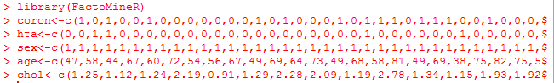

**y<-data.frame(coron,hta,sex,age,chol)**

**y**

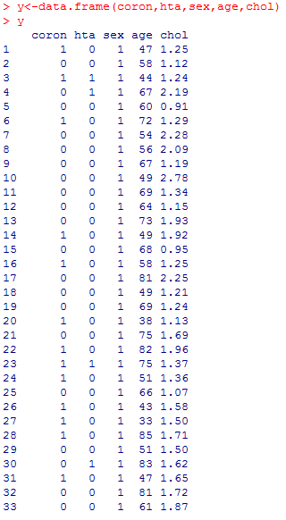

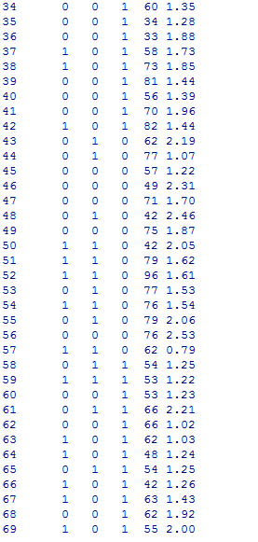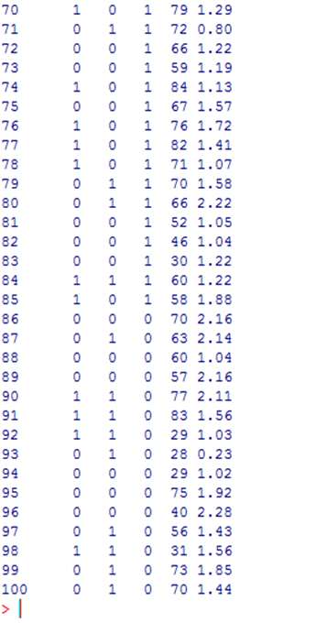

**données.glm<**

**glm(coron~hta+sex+age+chol,family=binomial(link=logit),data=y)**

**k<-données.glm**

**k**

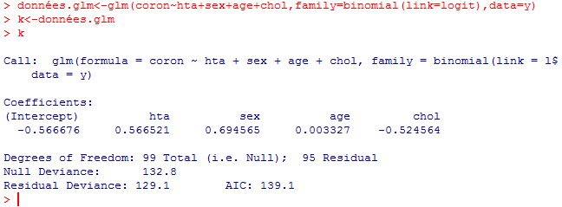

**summary(k)**

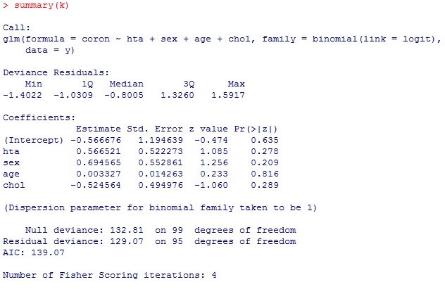

**plot(k)**

